Magpie Project Task #5 Arrays and the Magpie

1. Explain what code refactoring means.

Restructuring existing code

2. Provide a screen shot here of the required updates made to Magpie5. Provide screen shots of the code and evidence that your chatbot responds as intended.

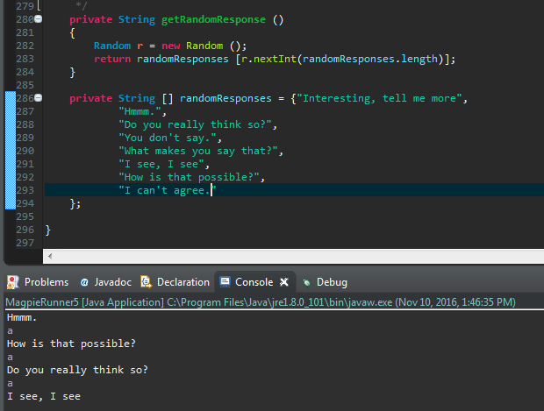

|  |  |  |  |  |
| --- | --- | --- | --- | --- |
| 50-59% | 60-69% | 70-79% | 80-89% | 90-100% |
| At least one of the modifications were attempted. Question is not answered. | Less than half of the modifications were attempted. Question is answered, but response is incorrect or incomplete. | Most modifications were attempted. Question is answered but is not thorough. | All required modifications were attempted. Questions is answered and is correct. | All required modifications were made as directed. Question is answered and expertly explained. |